|  |  |
| --- | --- |
| Memento | Command |
| Emoji.cs | Emoji.cs |
| FeatureFactory.cs | FeatureFactory.cs |
| LeftBrow.cs | LeftBrow.cs |
| LeftEye.cs | LeftEye.cs |
| Mouth.cs | Mouth.cs |
| RightBrow.cs | RightBrow.cs |
| RightEye.cs | RightEye.cs |
| Caretaker.cs | AddFeatureCommand.cs |
| Memento.cs | Command.cs |
|  | DeleteFeatureCommand.cs |
|  | Feature.cs |
|  | RemoveFeatureCommand.cs |
|  | StyleFeatureCommand.cs |
|  | User.cs |

Memento design uml:

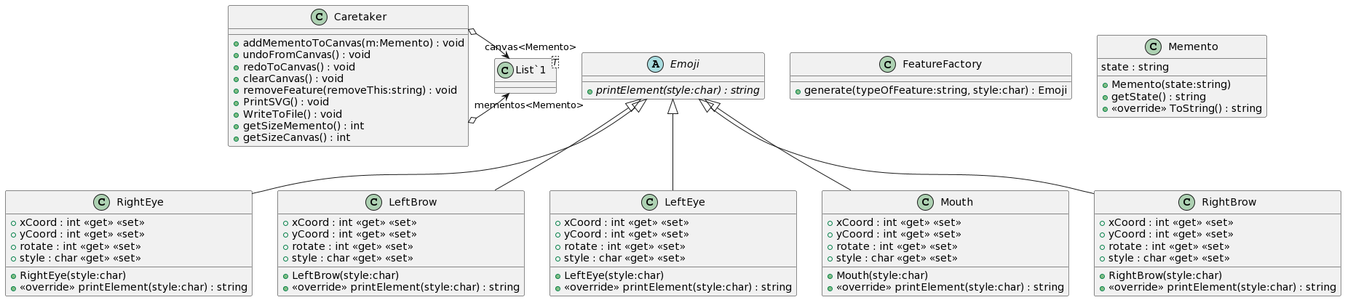

Command design uml:

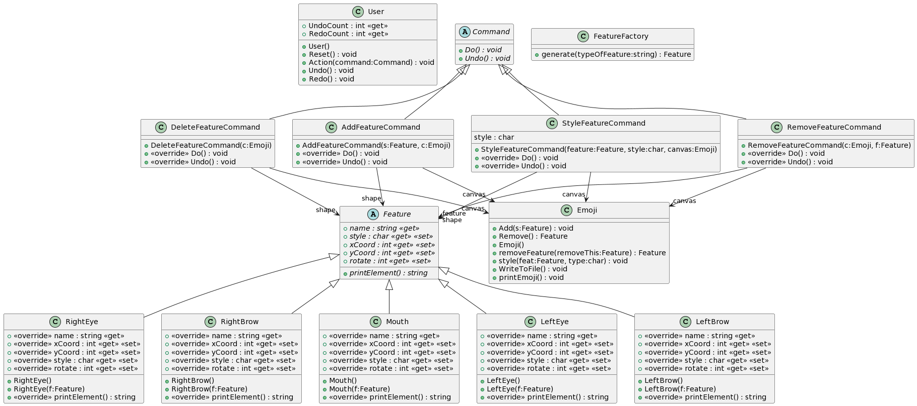

In my memento design I did a similar method to what I have done in past assignments where I save the actual string into my memento class. This makes it very difficult to make changes to it later. If I had more time, I would’ve liked to learn more about how to update instances of the object. Like the command design where it updates instances of the object to style it and so on. Being able to update the instance like in the command design allows me to easily add more functionality to the program. It might be a little more difficult to add the rotate and move to the memento design than it would the command design. I was very tempted to try adding rotate and move to the command design, but it is 3:38 AM. Another big difference between the 2 programs is that in the command design I made a Feature class that is basically an updated fancier version of my Emoji class in the memento design. And then the emoji class in the command design was basically like a canvas the caretaker class in memento. The emoji class in command took care of the lists and it is also where a lot of my methods for things are. Another design pattern I used in both Memento and Command is the factory pattern. This helped create my shapes and keep my main program file down to a minimum. Finally, if I had enough time to implement move and rotate to both my memento and command designs, I would have chosen to use the decorator pattern. This would allow me to add values to the things that already have set values like x and y coordinates to specific instances. And the decorator pattern also wouldn’t clutter up any of my other files.